**Module 3 – PL/SQL Programming**

**Exercise 1: Control structures**

**Scenario 1**: The bank wants to apply a discount to loan interest rates for customers above 60 years old.

**Question:** Write a PL/SQL block that loops through all customers, checks their age, and if they are above 60, apply a 1% discount to their current loan interest rates.

**QUERY:**

BEGIN

FOR cust IN (

SELECT CustomerID, DOB

FROM Customers

) LOOP

IF MONTHS_BETWEEN(SYSDATE, cust.DOB) / 12 > 60 THEN

UPDATE Loans

SET InterestRate = InterestRate - 1

WHERE CustomerID = cust.CustomerID;

DBMS_OUTPUT.PUT_LINE('Discount applied for Customer ID: ' || cust.CustomerID);

ELSE

DBMS_OUTPUT.PUT_LINE('No discount: Customer ID ' || cust.CustomerID || ' is under 60 years old.');

END IF;

END LOOP;

END;

/

**OUTPUT:**

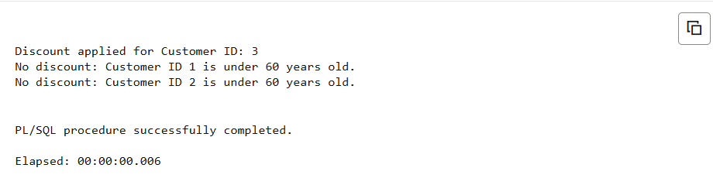

**Scenario 2**: A customer can be promoted to VIP status based on their balance.

**Question:** Write a PL/SQL block that iterates through all customers and sets a flag IsVIP to TRUE for those with a balance over $10,000.

**QUERY:**

ALTER TABLE Customers ADD IsVIP CHAR(1);

BEGIN

FOR cust IN (

SELECT CustomerID, Balance FROM Customers

) LOOP

IF cust.Balance > 10000 THEN

UPDATE Customers

SET IsVIP = 'Y'

WHERE CustomerID = cust.CustomerID;

DBMS_OUTPUT.PUT_LINE('VIP status set for Customer ID: ' || cust.CustomerID);

ELSE

DBMS_OUTPUT.PUT_LINE('Customer ID ' || cust.CustomerID || ' is not eligible for VIP.');

END IF;

END LOOP;

END;

/

**OUTPUT:**

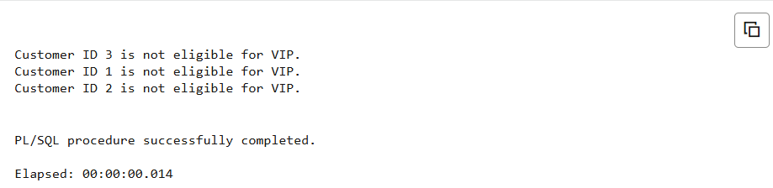

**Scenario 3**: The bank wants to send reminders to customers whose loans are due within the next 30 days.

**Question:** Write a PL/SQL block that fetches all loans due in the next 30 days and prints a reminder message for each customer.

**QUERY:**

BEGIN

FOR loan IN (

SELECT LoanID, CustomerID, EndDate

FROM Loans

WHERE EndDate BETWEEN SYSDATE AND SYSDATE + 30

) LOOP

DECLARE

v_name Customers.Name%TYPE;

BEGIN

SELECT Name INTO v_name FROM Customers WHERE CustomerID = loan.CustomerID;

DBMS_OUTPUT.PUT_LINE('Reminder: Loan ID ' || loan.LoanID || ' for customer ' || v_name || ' is due on ' || TO_CHAR(loan.EndDate, 'DD-MON-YYYY'));

END;

END LOOP;

END;

/

**OUTPUT:**

